Name |  |  |  |  | Please attach  a recent photo  here.
 | First name Middle name Family name (in capital letters) |  |  |  | Please attach  a recent photo  here.
Nationality |  | Passport no. |  |  | Please attach  a recent photo  here.
Date of birth |  | Gender | Male Female |  | Please attach  a recent photo  here.
Date of birth | Day / Month / Year | Gender |  |  | Please attach  a recent photo  here.
Affiliation / Name of school: |  | Major / Year |  |  | Please attach  a recent photo  here.
Mailing address: |  | Tel. / Mobile
 |  | Fax
 |  | E-mail
Name of emergency contact person (relationship): |  |  |  | Tel. / Mobile:
Address: |  |  |  | E-mail:
Language Proficiency: English  ◻ Excellent ◻ Good ◻ Fair ◻ Poor |  |  |  | Other languages:
How did you learn about the BroSis Project?
◻ Government organization ◻ School ◻ Internet ◻ Youth Center ◻ Friend/Family ◻ Other

Briefly introduce yourself and describe your relevant international and cultural exchanges experiences or voluntary works:

Tell us what you would like to gain from participating in the BroSis Project:
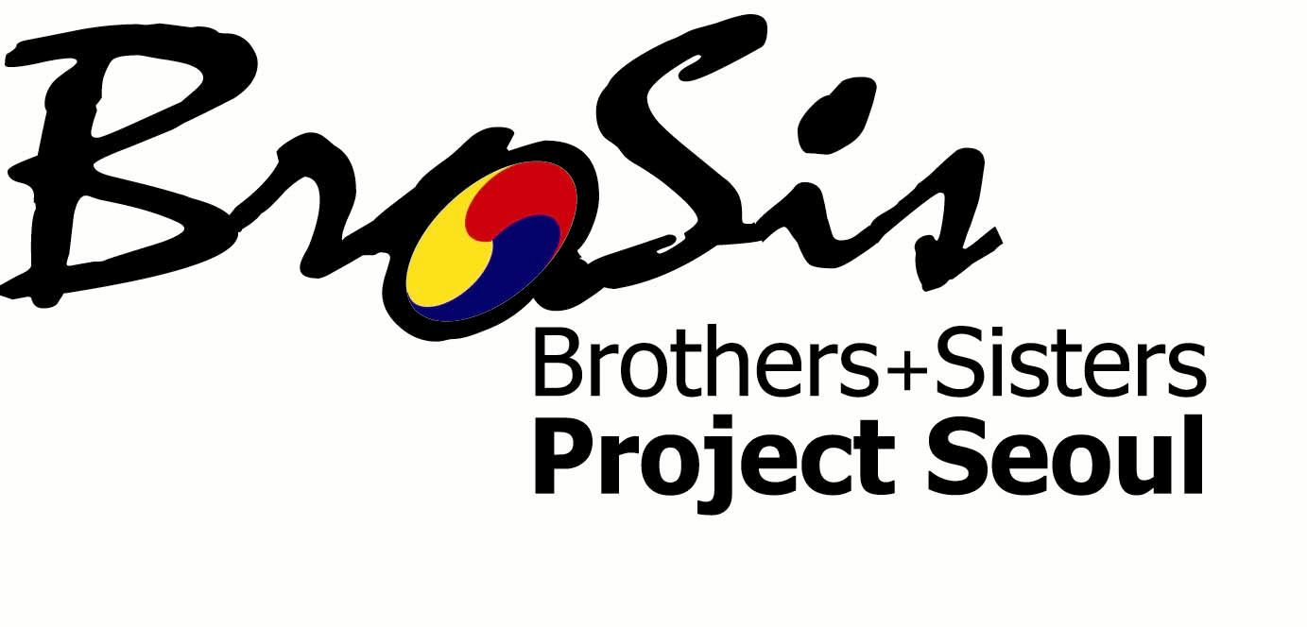

2008 BroSis Project Application Form
-Youth Participation for the Sustainable Development of Cities-
Seoul, Republic of Korea / July 1 –11, 2008

Write an essay addressing ONE of the following topics (your essay must be at least 500 words / attach additional sheets if necessary): ① What does “the sustainable development of cities” mean to you, and which issue in terms of the sustainable development of cities is most popular in your city, and why? ② Among the different fields such as environment, education, economics, urban planning, public services, etc., which field do you think cities need to develop further in terms of sustainable development, and why? ③ What practical steps should cities take for the sustainable development of cities, and why?

I, the undersigned, certify that the information supplied in this application form, to the best of my knowledge and belief, is true, accurate and complete.

Date _____________________ Name_______________________________ Signature___________________________

Please submit your completed application to brosis@mizy.net no lather than May 30, 2008.

Inquiries:
Sophia Ji-hye Yoon (Ms.)
Project Coordinator

Seoul Youth Center for Cultural Exchange (MIZY Center)
Tel: 82-2-755-1024 (Ext. 104)
Fax: 82-2-755-7057
MIZY Center website: http://www.mizy.net/eng/
BroSis Project website: http://brosis.mizy.net/

