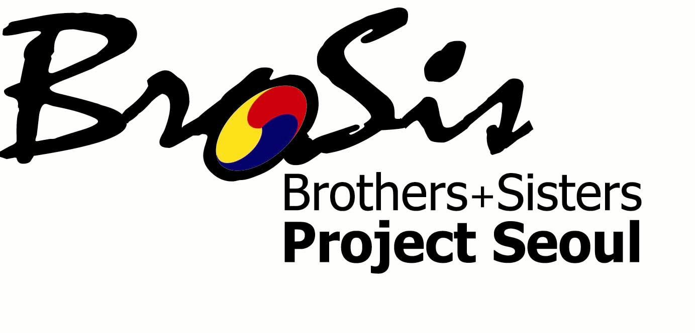

Youth Participation for the Sustainable Development of Cities

Seoul, Republic of Korea / July 1 – 11, 2008

General Information

1. Background
Since 1985 when the United Nations initiated International Youth Year, which reiterates youth involvement in the decision-making process in various areas, the emphasis on youth participation in peace and development has increasingly gained momentum. In keeping with this spirit, the Seoul Youth Center for Cultural Exchange (MIZY Center), with the support of the Seoul Metropolitan Government and the Korean National Commission for UNESCO, will host the 3rd 2008 BroSis (Brothers+Sisters) Project: Youth Participation for the Sustainable Development of Cities, to be held from July 1 to 11, 2008 in Seoul, Republic of Korea.

Seoul has long been recognized as one of the oldest, most densely populated and digitally connected cities in the world. Since hosting the Summer Olympic Games in 1988, the economic, political and cultural interactions between Seoul and her sister cities have grown and strengthened. Youth exchanges, however, are hardly found in these streams of interactions.

The sustainable development of cities has been a major concern among policy makers, administrators, and even youth. By learning about the issues facing other metropolitan areas, youth can gain insight and wisdom into how they, as citizens, can take collective action with other youth to improve the conditions of their own cities. The 1st BroSis Project was held in 2006 to provide this opportunity for twenty-five youth participants from six cities. The 2nd BroSis Project in 2007 doubled the number of participants as forty-six from nineteen cities. Active participation was a huge contribution to last year's success.

Under the theme of youth participation for the sustainable development of cities, this 3rd annual BroSis Project will provide youth participants a chance to collectively tackle and discuss several key issues, and a network to exchange thoughts and ideas with other youth.

The MIZY Center would like to invite 40 international participants from Seoul’s sister cities and the cities that have signed MOU with the Seoul Metropolitan Government to conduct research with 20 Korean participants on Seoul and its efforts to realize sustainable development. The 60 international and Korean youth participants will be divided into 5-6 groups, and each group will focus on a specific theme regarding the sustainable development of cities. Participants will study and share ideas through the project website: http://brosis.mizy.net, as well as conduct field research at various locations including governmental institutions. By conducting research and engaging in a variety of cultural activities in support of this theme, this project provides youth the extraordinary opportunity to network with peers from all around the world. Together, youth participants can discover a variety of solutions to the similar problems faced by the cities from which they come. In addition, the media will play an important role in support of this event by promoting public awareness of the sustainable development of cities.

2. Organization
Organized by
Seoul Youth Center for Cultural Exchange (MIZY Center)

Supported by
Seoul Metropolitan Government
Korean National Commission for UNESCO

About us: What’s the MIZY Center?
Founded in May 2000 by the Seoul Metropolitan Government, the Seoul Youth Center for Cultural Exchange (MIZ Center) is dedicated to the promotion of cultural exchanges among youth. The MIZY Center organizes various kinds of cultural exchange activities, such as personnel exchanges (i.e., dispatching Korean youth and hosting foreign youth), exhibitions of Korean and international artworks, and forums on international relations and culture. The MIZY Center also cooperates and assists in projects aimed at cultural diffusion and understanding. Since its opening, the MIZY Center is operated by the Korean National Commission for UNESCO under the auspices of the Seoul Metropolitan Government, and aims to inspire youth to create a better and peaceful world in which every culture is treated with equal respect.

3. Dates
July 1 – 11, 2008 (11 days / 10 nights)

4. Qualification of Participants
We plan to invite 40 international participants this year. We seek a gender-balanced and diverse pool of delegates who represent different cities across the globe.
* Please note that a maximum of 2 participants will be selected from each city.

If you wish to participate in the 2008 BroSis Project, you would be…
- A youth between the ages of 18 and 24 who lives in one of Seoul’s sister cities or in a city that has signed MOU with the Seoul Metropolitan Government
  - Seoul’s sister cities: 22 cities
Taipei (Taiwan), Ankara (Turkey), Honolulu (USA), San Francisco (USA), Sao Paulo (Brazil), Bogota (Colombia), Jakarta (Indonesia), Tokyo (Japan), Moscow (Russia), New South Wales (Australia), Paris (France), Mexico City (Mexico), Beijing (China), Ulanbator (Mongolia), Hanoi (Vietnam), Warszawa (Poland), Cairo (Egypt), Rome (Italy), Astana (Kazakhstan), Washington D.C (USA), Athens (Greece), Bangkok (Thailand)
  - Cities that have signed MOU with the Seoul Metropolitan Government: 8 cities
Ottawa (Canada), Berlin (Germany), Amsterdam (The Netherlands), Budapest (Hungary), Istanbul (Turkey), Tashkent (Uzbekistan), Los Angeles (USA), Milan (Italy)
- Willing to study Korea- and Seoul- related information posted on our website (available beginning in mid-May), prior to the start of the program.
- Proficient in written and spoken English.
- Able to communicate and work effectively in a team setting.
- Interested in or studying one or more of the following subjects.
  - Korean culture, Korean history, or other Korea- and Seoul related subject;
  - Urban planning and design, development or reconstruction;
  - Environmental issues, energy and/or natural resources;
  - International and cultural exchanges, multicultural society;
  - Youth participation, education;
  - Or other sustainable development-related studies.
- Capable of performing all scheduled activities.

5. Major Activities
  - Study: Read up on the project! There will be on-line assignments on the project’s theme that will be posted on our website. You may be asked to post information about your city and its efforts to promote sustainable development. The website will also provide participants with general information, self-introductions, and further information on Seoul and Korean culture.
  - Research: Participants from all around the world will conduct research on the sustainable development of cities. Each team will gather for lecture meetings, discussions and field trips that focus on urban sustainable development and its future.
  - Roundtable: Participants will present their team’s research results to a variety of different audiences, including high officials of the Seoul Metropolitan Government, and take part in exchanges and dialogues that focus on the various means, interests and aspirations of sustainable development.

6. Itinerary (subject to change)

 | Morning | Afternoon | Evening
July
1st  (Tues) | Arrival  Registration |  | Opening Ceremony Welcome Party
2nd  (Wed) | Lecture part 1 | Lecture part 2 | International Night
3rd  (Thur) | Field Trip Research |  | Research Preparations
4th  (Fri) | Field Trip Research
5th  (Sat) | Seoul Sightseeing Tour |  | Home-stay at Korean Participants’ Homes
6th  (Sun) | Cultural Activities
7th  (Mon) | Preparing the Research Presentation
8th  (Tues) | Preparing the Research Presentation
9th  (Wed) | Final check of presentation | Roundtable with the concerned officials  of the Seoul Metropolitan Government
10th  (Thur) | Evaluation | Down Time | Gala Dinner  Closing Ceremony
11th  (Fri) | Departure

7. Working Language
The working language of the forum is English. If and when necessary, English and/or Korean interpretation will be provided.

8. Application
Please fill out the application form provided and send the completed application form to the MIZY Center by e-mail: brosis@mizy.net
* Please note: The application deadline is May 30, 2008.
Once you submit your application to the MIZY Center, you will receive a confirmation email from the organizer.

9. Financial Aid
The MIZY Center will cover the expenses for: a portion of your round-trip air travel (please see details below), all meals and accommodation, transportation within the host country, admission fees for program-related events, and health and accident insurance for the duration of the program from July 1 to 11.

Air Travel Expense Allowance:
- For participants who arrive from the Asian region: USD 200
- For participants who arrive from regions other than Asia: USD 400
** You must send us a copy of your passenger receipt prior to your arrival in Seoul. Upon your arrival in Seoul, you must provide us with your original passenger receipt in order for us to reimburse you.

The MIZY Center will NOT provide: visa application fee, personal spending money, required travel documents and immunizations.

10. Accommodations
Seoul International Youth Hostel
San 4-5, Yejang-dong, Jung-gu, Seoul 100-250, Korea
Tel: 82-2-319-1318
Website: http://www.seoulyh.go.kr/

11. Booking Air Flights and Applying for a Visa
- Applying for a visa: Upon your selection and registration as a participant, we will send you an official invitation letter to support your visa application. However, please note that this letter does not guarantee visa approval.
- Flight booking: All selected international participants are responsible for booking their own air travel. The nearest airport to the MIZY Center is the Incheon International Airport [ICN]. The MIZY Center will provide airport pick-up free-of charge.

12. Contact Person
Sophia Ji-hye Yoon (Ms.)
Project Coordinator
Seoul Youth Center for Cultural Exchange (MIZY Center)
Youth Hostel 2F, San 4-5 Yejang-dong Jung-gu, Seoul 100-250, Korea
Tel: 82-2-755-1024 (Ext.104) / Fax: 82-2-755-7057 / E-mail: brosis@mizy.net
MIZY Center website: http://www.mizy.net/eng/
BroSis Project website: http://brosis.mizy.net/

